|  |  |
| --- | --- |
| **TEAM ID** | **PNT2022TMID14038** |
| **PROJECT NAME** | **Exploratory Analysis Of Rain Fall Data In India For Agriculture** |

PROJECT FLOW

To accomplish this, we have to complete all the activities and tasks listed below Data Collection

* Collect the dataset Data Pre-processing
* Import the Libraries.
* Importing the dataset.
* Checking for Null Values.
* Data Visualization.
* Taking care of Missing Data.
* Label encoding.
* One Hot Encoding.
* Feature Scaling.
* Splitting Data into Train and Test. Model Building
* Training and testing the model
* Evaluation of Model Application Building
* Create an HTML file
* Build a Python Code

**Diagram:**

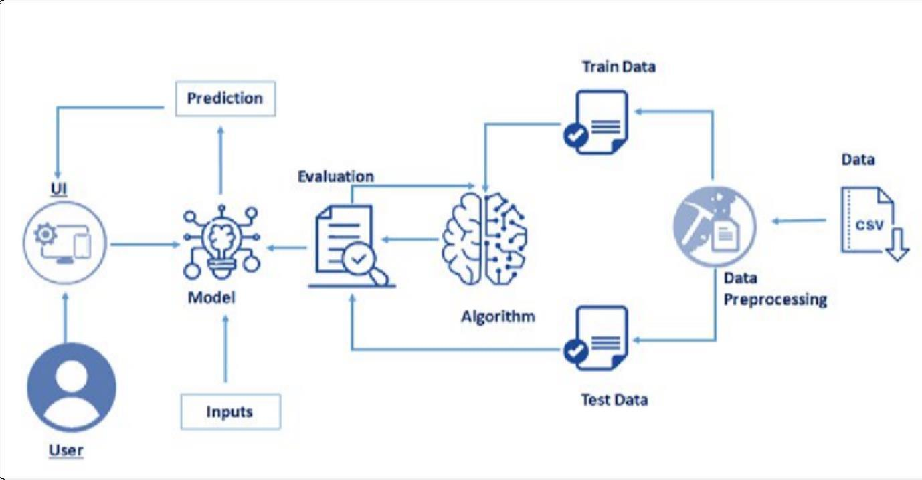

**Final Output:**

* User interacts with the UI (User Interface) to enter the input values
* Entered input values are analyzed by the model which is integrated
* Once the model analyses the input the prediction is showcased on the UI